Commercial TnH+IAQ Sensor with WIFI-MQTT Communication
1. Product Overview
WIN-SN-TnH-IAQ-W is a versatile data acquisition device designed for real-time monitoring in industrial applications, providing flexibility for various measurements. The device integrates seamlessly into cloud infrastructures via Wi-Fi over MQTT, offering reliable wireless communication and secure remote data telemetry, making it ideal for large-scale, distributed IoT installations.
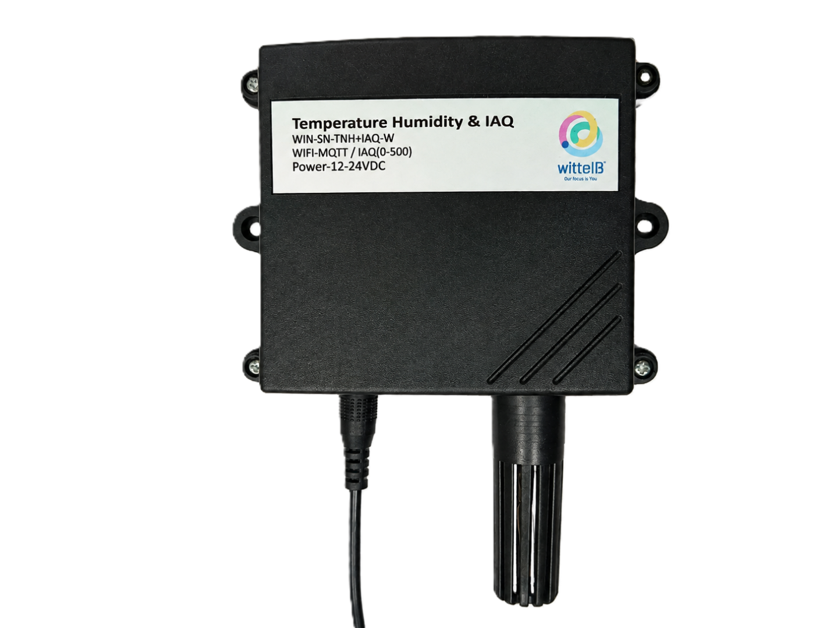
Its robust design makes it suitable for installations in HVAC systems, environmental monitoring, and process control. With configurable data sampling rates, multi-sensor compatibility, and easy configuration, the WIN-SN-TnH-IAQ-W ensures accurate Air-quality, Temperature, and Humidity data acquisition alongside reliable performance in demanding environments, making it an excellent choice for both commercial and industrial IoT applications.

Ex: - Product Image

2. Technical Parameters
- Measuring Parameters of Indoor Air Quality, Temperature, and Humidity.
 | Sensor Name | Temperature Measuring Range | Humidity Measuring range | AQI/ GAS/  Pressure | Measuring  Accuracy
☐ | BME280 | -40 ~ 85°C | 0~100% RH. | 300 - 1100 hPa | 1.0°C, 3.0 %RH,  1.0 %hPa
☒ | BME680 | -40 ~ 85°C | 0~100% RH. | 300 - 1100 hPa  & 0 – 500 IAQ | 1.0°C, 3.0 %RH,  0.6 %hPa, 15 %IAQ
☐ | BME688 | -40 ~ 85°C | 0~100% RH. | 300 - 1100 hPa  & 0 – 500 IAQ | 0.5°C, 3.0 %RH,  0.6 %hPa, 15 %IAQ
☐ | BME690 | -40 ~ 85°C | 0~100% RH. | 300 - 1100 hPa  & 0 – 500 IAQ | 0.5°C, 3.0 %RH,  0.5 %hPa., 15 %IAQ

3. Sensor Specifications
- Wide temperature range: −40 °C to +125 °C
- Full humidity range: 0 % to 100 % RH
- Power supply DC: 12-24V@1A.
- Product dimension: 85*85*36 mm.

- Certifications:

4. Power Supply Connection
DC Connection
- Use 12-24V@ 1A, Power supply.
- Don’t make loose connection.

5. Step-by-Step Configuration
- Connect the Device
  - Connect 12v-1A DC adaptor to power the board
  - Connect the Wi-Fi:- WIN-SN-TnH-IAQ -W, Password:- 12345678
  - Search browser, enter default IP : 192.168.4.1
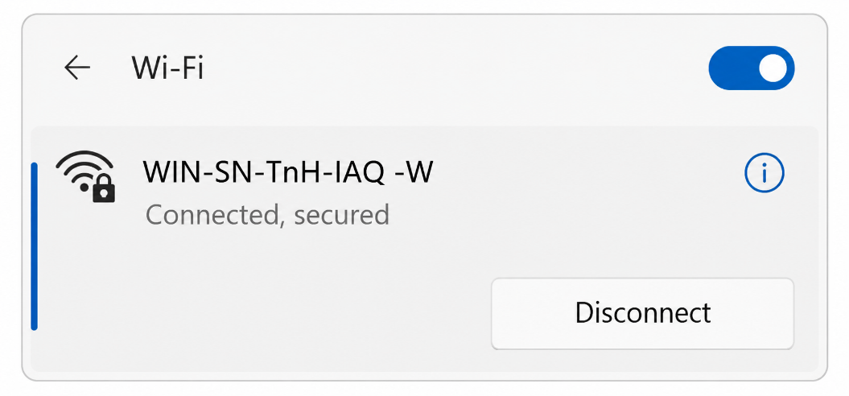
  - The device starts communication using default settings if not previously modified.

- WIFI & MQTT Configuration:

- Device & Wi-Fi Configuration
These settings identify the device and connect it to your local network.
- Device ID: Enter a unique name (e.g., IAQ1) used to identify the monitor on your network and cloud platform.
- Wi-Fi SSID: Input the name of your local wireless network (e.g., WittelB).
- Wi-Fi Password: Enter the security key for the selected Wi-Fi network.
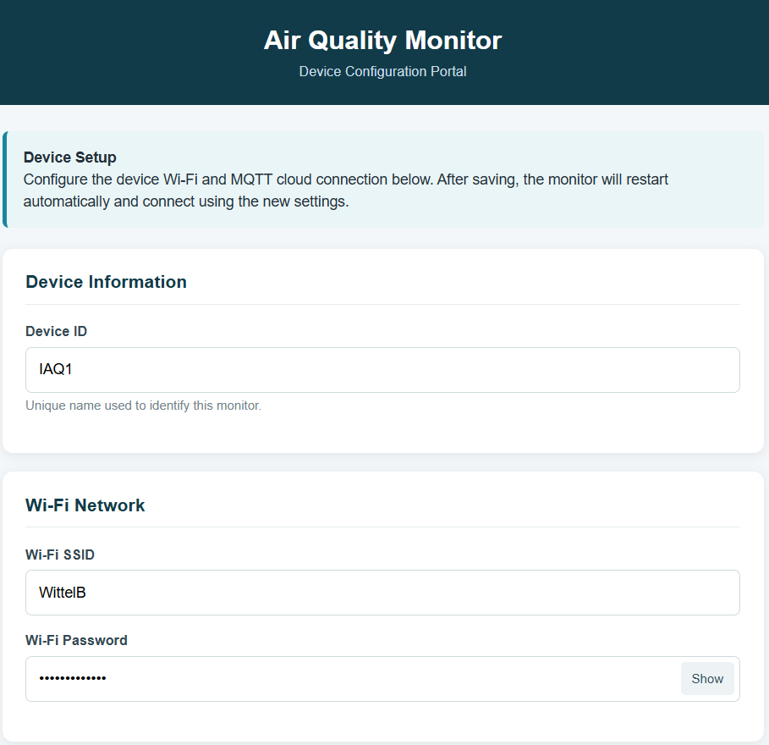

- MQTT Cloud Configuration
These settings govern how the device securely transmits telemetry data to your cloud dashboard.
- MQTT Broker: Enter the server address provided by your MQTT service (e.g., mqtt.eu.thingsboard.cloud).
- MQTT Port: Input the specific port number used by your broker (e.g., 1883).
- MQTT Security: Use the dropdown to select Standard MQTT, or choose TLS/SSL if your broker requires a secure connection.
- MQTT Username & Password: Provide your specific authentication credentials to allow the device to publish data to the broker.
- Publish Topic: Define the exact MQTT topic path (e.g., v1/ devices/ me/ telemetry) where the sensor readings will be published.
- Data Publish Interval: Configure how frequently the device sends data (from 1 to 60. Default: 5 Sec.) and specify the time unit, such as Seconds & Minutes.
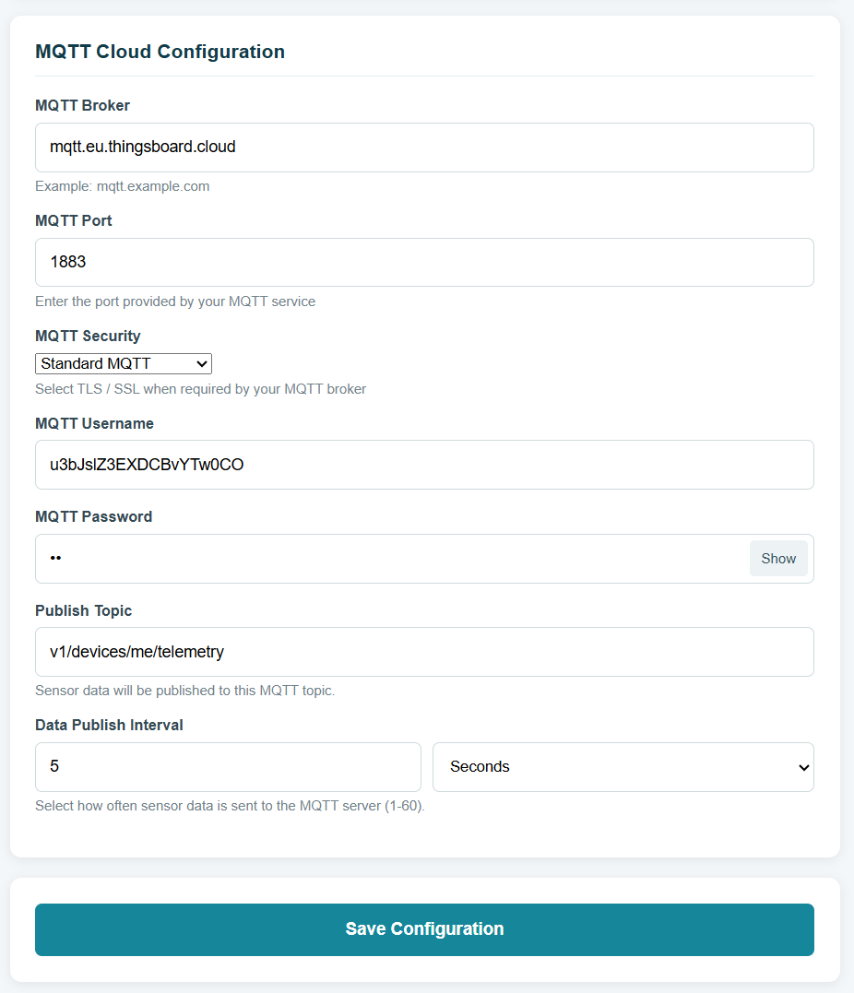
- Save Configuration: Click this button at the bottom of the page to commit the credentials. The monitor will automatically restart and connect using the newly saved settings.

- Factory Reset
This section is used for complete device wipe and reconfiguration.
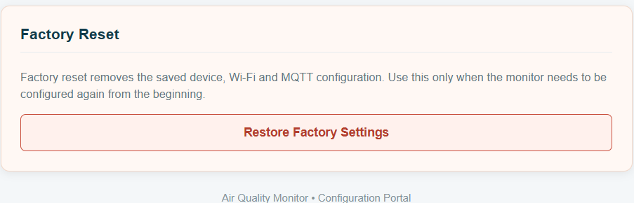
- Restore Factory Settings: Clicking this button initiates a factory reset, which completely removes all saved Device, Wi-Fi, and MQTT configurations.

Important note:
- Always-On Configuration Wi-Fi: The device's Access Point (AP) remains continuously active while powered on, even after successfully connecting to your local Wi-Fi and MQTT broker.
- This allows you to connect to the configuration webpage at any time to easily update settings on the fly without needing to reset the device.

Contact Information
Augmatic Technologies Pvt. Ltd.,
Plot no 6, Shah Industrial Estate II,
Kotambi, Vadodara – 391510.
Email – Sales@wittelb.com
Support: support@wittelb.raiseaticket.com / +91 94038 92805

